OP PROCESS

Adding thread group to the test plan

Then adding os process sampler to the thread group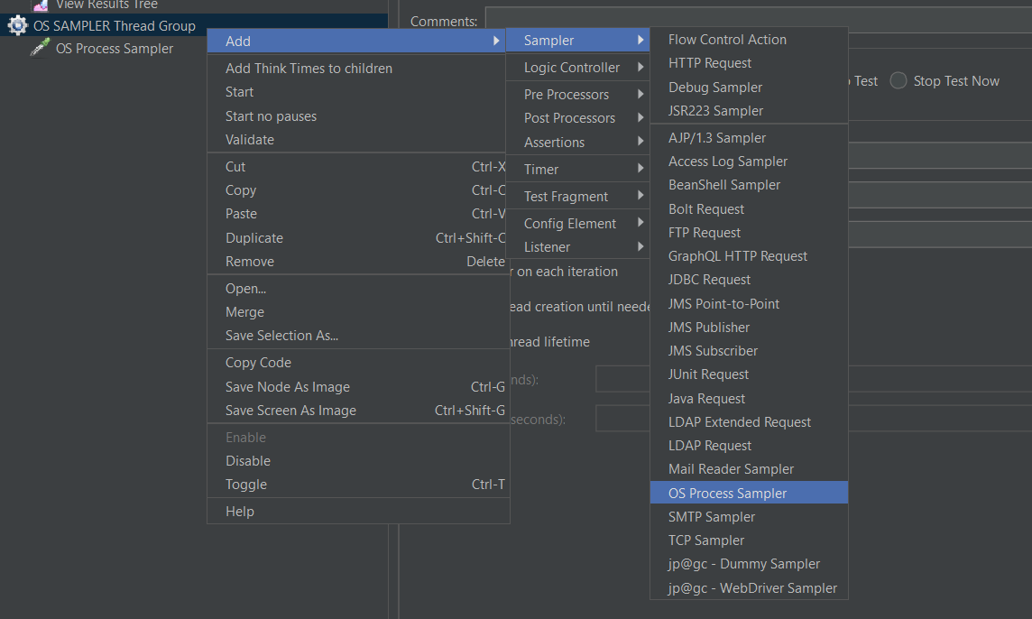

In os process giving command as - ipconfig

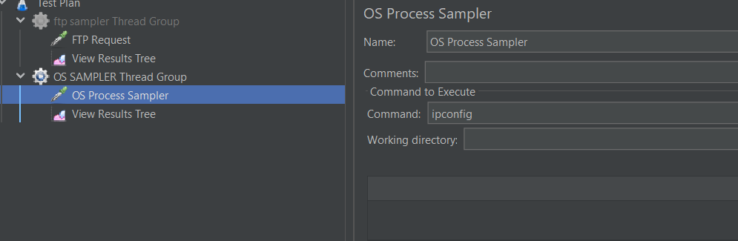

Click on the run button to see the result in the view result tree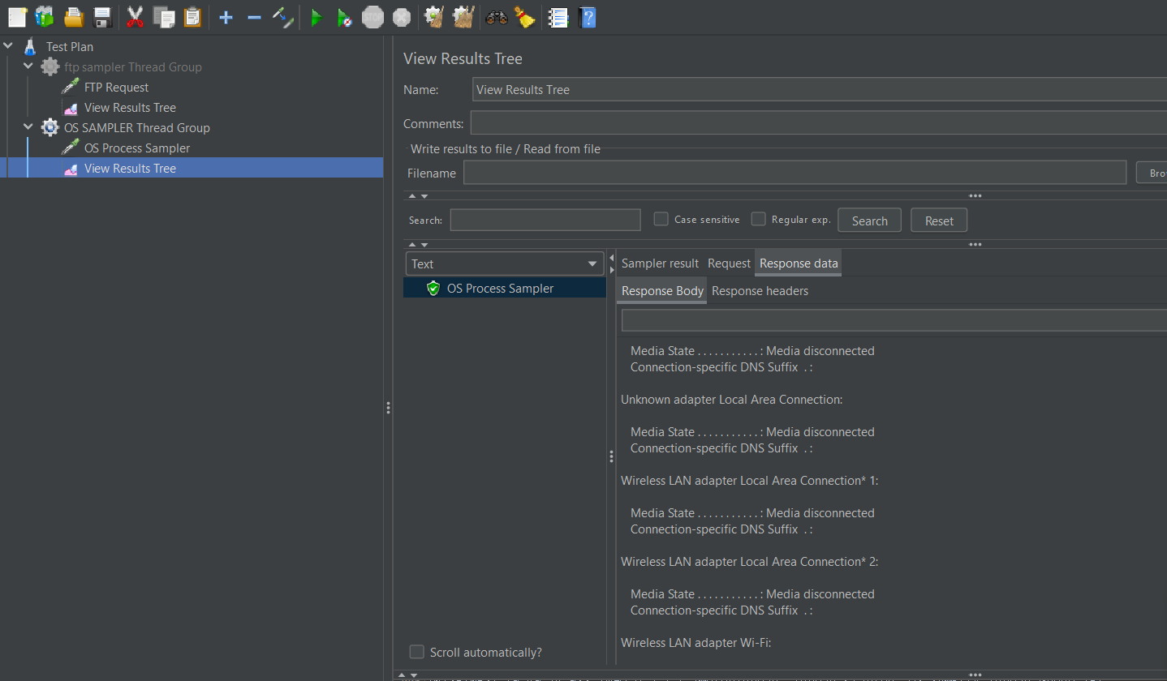

DEBUG SAMPLER

Then added debug sampler in the thread group

And call the object in the debug sampler name -${ }

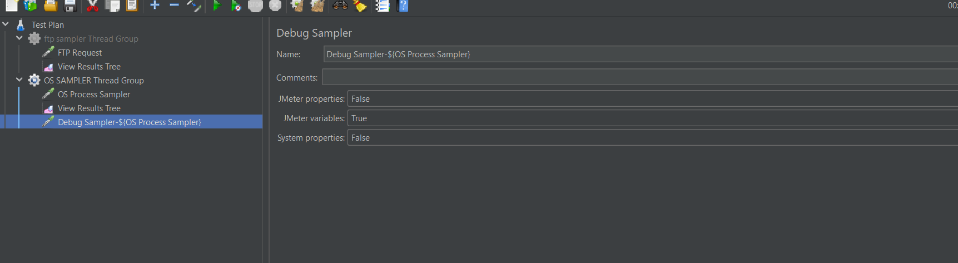

Then click on the run button to see the result In the view result tree.